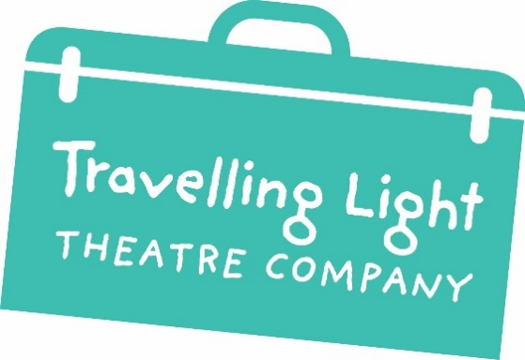

Volunteer Induction Pack for
Participation

Travelling Light
Travelling Light creates outstanding theatre for and with young people that inspires their thinking, engages their emotions and fires their imaginations.
Since 1984 we have sparked the creative journey of over one million young people in our locality of Barton Hill, throughout Bristol and beyond.
We're a registered charity and part of Arts Council England’s National Portfolio and Bristol City Council’s Cultural Investment Programme. We rely on our funders, donors, supporters and Friends to enable us to keep inspiring thousands of children and young people through theatre.

Supporting Volunteers
Volunteers help us achieve everything that we do. You don't need any previous experience, just a willingness and ability to commit your time.
Our volunteers enjoy working with us and often gain valuable experience and contacts. But don't just take our word for it. This is what some of the volunteers we have worked with said:

“I enjoyed meeting lots of people involved with Travelling Light and being able to watch some performances too.”

“You get to work with lovely people, get involved with the community and see some shows too! Volunteering with Travelling Light is fun and inspiring!”

Volunteer Role Description
Participation Volunteer
The participation programme is an essential part of Travelling Light’s work. The company runs a regular youth theatre programme as well as one-off workshops and long-term projects with schools.
Projects
Projects that the post could include:
- Assisting with our regular youth theatre groups (7-19s, Louder Than Words & ActionSpeak) or on one-off or short-term drama projects within the Bristol area.
- Helping with our creative learning programme within schools, colleges and early years provision on long term or one-off projects, such as T-Lights or Play in A Week.
- Co-productions or collaborative projects with other arts or community organisations.

Volunteer Brief:
These projects could involve some of the following responsibilities:
- To assist the Creative Learning Officer and Youth & Community Officer on administrative or preparatory tasks for projects during the placement period.
- To support the project facilitators / directors and participants during workshops, rehearsals or performances.
- To assist with ensuring all participants are looked after and health and safety needs are met whilst they are taking part in project activities.
- To support the design and construction of set, prop and costumes for the projects, as well as sourcing materials where required.
- To help out with performances either as an assistant stage manager, or a steward.
- To assist with project documentation.

Person Specification:
- Enjoys working with children and young people
- Values young people’s opinions
- A good listener
- Reliable and honest
- Confidence to contribute ideas
- Works well within teams
- Willing to learn new skills
- Well organised
- A creative person

Opportunities:
- Opportunity to work with a professional theatre company
- Opportunity to be a part of something for the good of the community
- Opportunity to meet new people
- Opportunity to support young people’s creativity

Recruitment
Travelling Light will use appropriate means to advertise for volunteers, which take into account the principles of our Equality, Diversity & Inclusion Policy. Applicants will be interviewed and a DBS check will be made (when required) for every volunteer.

Induction and Training
There will be an induction session delivered by the Travelling Light team. This will include:
- The role of the volunteer
- An introduction to other staff and volunteers
- Access to all relevant policies such as Health and Safety, Code of Conduct and Child Protection which are stored on the Volunteer Google Drive: tinyurl.com/m83upshm
- Any relevant Safeguarding training
- Induction to the space they will be working in
- Role description and agreement

Expenses
We value our volunteers and want to ensure that there are no barriers to volunteer involvement. All volunteers can claim up to £5 a day to cover out-of-pocket expenses, including travel and meals. In order to claim expenses, an expenses form must be completed and returned to the General Manager with relevant receipts.
Support
Our team will offer support to our volunteers throughout their placement. There will be a briefing/induction at the beginning and a debrief at the end. Our staff are happy to book in additional meetings with volunteers to discuss any problems or issues that may arise.
Managing Absence
If you are unable to attend a session, we would appreciate it if you called into the office at your earliest opportunity, stating the reason for your absence and the possible duration of your absence, if on-going. The Office number to call is 07305 015081.
Insurance
By signing an agreement all volunteers are covered by our Employer’s Liability Insurance.
Data Protection
Travelling Light will follow all current data protection legislation. In adherence with our Data Protection & Safeguarding Policies, your personal data will be securely retained for 30 years. Copies of our Data Protection policy and procedures are available from the General Manager.
Confidentiality
Volunteers will not at any time, except so far as is necessary in the ordinary course of your placement, disclose to any person, any confidential, financial or procedural information as to the affairs of Travelling Light which may come to your knowledge in the course of your placement.
Resolving Problems
It is important for Travelling Light to maintain its standards of service and it is also important that volunteers enjoy making a contribution to the service.
Any problems that may arise whilst volunteering will be dealt with as follows:
- An informal chat with team members.
- If the problem still persists, a meeting will be arranged with the project lead.
- If following this meeting, the issue remains unresolved you can make a written complaint.
- Following a written complaint a formal meeting will be arranged. You are welcome to be accompanied by a friend to this meeting.
The agreement between Travelling Light and the volunteer is entirely voluntary and does not imply any contract. Both parties are able to end the volunteer agreement at any time without notice.

