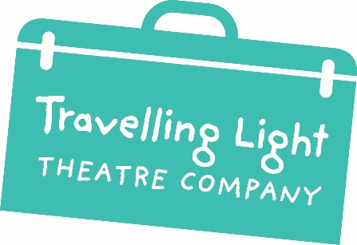
Travelling Light Theatre Company
@ Barton Hill Settlement
43 Ducie Road
Barton Hill
Bristol BS5 0AX
UK

Tel: +44 (0) 117 377 3166
Fax: +44 (0) 117 377 3167
Email: info@travellinglighttheatre.org.uk

Volunteer Expression of Interest Form

PLEASE FILL IN ALL SECTIONS OF THIS FORM

CONTACT DETAILS
First Name(s) | Surname
Other names you may have been known by | Date of Birth
Present Address | Email
Mobile Number  Home Number | DBS number (if applicable)  Date  Update Service no
EMERGENCY CONTACT DETAILS
Name  Relationship to you | Contact number
IF YOU ARE CURRENTLY IN EDUCATION…
Where are you studying? | Who is your main teacher?
Their contact details? | What are you studying?
IF YOU ARE WORKING…
Name of current employer | Their contact details
Your job title | Brief description of role
I am not currently in Employment, Education or Training □
ABOUT YOU
WHEN would you like to volunteer with Travelling Light?

WHY would you like to volunteer with Travelling Light?

Are there aspects of Travelling Light you are particularly interested in? (tick all that apply)

Regular weekly Youth Theatre groups:
□ 4-6s (Weds 16.30-17.30)
□ 7-10s (Thurs 16.15-17.30)
□ 11-13s (Thurs 18.00-19.30)
□ 14-19s (Weds 18.00-19.30)
Regular weekly Youth Theatre groups for disabled young people:
□ 7-15s (Mon 17.30-18.30)
□ 16-25s (Weds 19.00-20.30)

□ Work in schools/colleges (all ages)
□ Supporting productions
□ Costume/set design
□ Script Writing
□ Supporting Events e.g. Festivals
□ Marketing
□ All of the above

Any other additional training of experience? E.g. First Aid

REFERENCES
REFEREE 1  Name  Contact | REFEREE 2  Name  Contact
I agree that all the above information is correct to the best of my knowledge

Signed  Date | Name (printed)

Thank you.
This information is strictly confidential and will not be available to third parties.

Would you like to sign up for our e-newsletter? If so, tick here

