PRIVACY STATEMENT | To inform you why we collect your personal information and that of your child.
How we use your information: By completing this form you have given Travelling Light CONSENT to store your personal contact details for the purposes of running the youth theatre register of interest database. You can also choose to receive our enewsletters.
How we store your information: All information given on this form is strictly confidential. We have restricted access controls for both printed/paper and digital documents, as per our Data Protection policy. We never share personal contact information with third parties without consent. Unless you object, personal information is kept for a period of 1 year from the date of submission. Following 1 year we will send you an email to check if you would like to remain on the Register of Interest database.
Your rights: You have the following rights under the General Data Protection Regulations 2018: Right to withdraw consent, right to correction, right to deletion, right to access.
Who to contact: If you have any queries regarding how we use your data, please contact the Youth Theatre Coordinator: takepart@travellinglighttheatre.org.uk
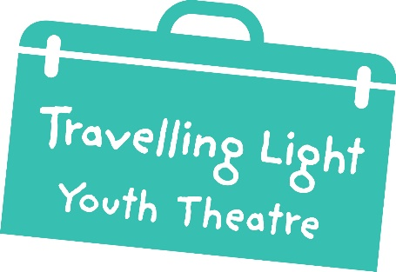Register of Interest

