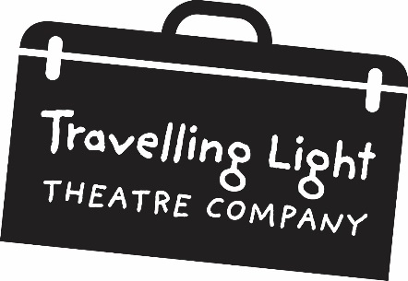
EQUAL OPPORTUNITIES MONITORING FORM

CONFIDENTIAL

Travelling Light is working towards increasing the company’s diversity in all aspects of its work. We are also asked by the Arts Council to give statistical information about the people we employ during the course of our work. To enable us to collect accurate information we would appreciate it if you could you fill in this form. All information is strictly confidential, is provided for monitoring purposes only, and is not linked to any personal record on employees held by Travelling Light.

 | White |  |  |  | Mixed
 | British |  | □ |  | White & Black Caribbean |  |  | □
 | Irish |  | □ |  | White & Black African |  |  | □
 | Gypsy or Irish Traveller □  Any other white background (please specify) |  |  |  | White & Asian |  |  | □
 |  |  |  |  | Any other mixed background (please specify)
 | Black |  |  |  | Asian
 | Caribbean |  | □ |  | Indian |  |  | □
 | African |  | □ |  | Pakistani |  |  | □
 | Any other black background (please specify) |  |  |  | Bangladeshi |  |  | □
 |  |  |  |  | Chinese |  |  | □
 |  |  |  |  | Any other Asian background (please specify)
 | Any other ethnic group (please specify) |  |  |  | Arab |  |  | □

Gender: With which gender do you currently identify?
Male □ |  | Female □ |  |  |  | Prefer not to say | □

Disability: Do you consider yourself to be disabled?
Yes |  | □ |  |  |  | No | □

Age: How old are you?

0-19 □ 20-34 □ 35-49 □ 50-64 □ 65+ □

