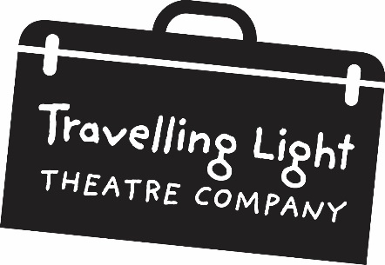

**EQUAL OPPORTUNITIES MONITORING FORM**

**CONFIDENTIAL**

Travelling Light is working towards increasing the company’s diversity in all aspects of its work. We are also asked by the Arts Council to give statistical information about the people we employ during the course of our work. To enable us to collect accurate information we would appreciate it if you could you fill in this form. The information you give to us will be treated in the strictest confidence. Thank you for your help.

|  |  |  |  |  |  |  |  |  |
| --- | --- | --- | --- | --- | --- | --- | --- | --- |
| White | | |  | Mixed | | |  |  |
| British | | |  | White & Black Caribbean | | |  | |
| Irish | | |  | White & Black African | | |  | |
| Gypsy or Irish Traveller | | |  | White & Asian | | |  | |
| Any other white background *(please specify)* | | |  | Any other mixed background (*please specify)* | | |
|  |  | |  |  | | |  |  |
|  |  | |  |  | | |  |  |
| Black | | |  | **Asian** | | |  |  |
| Caribbean | | |  | Indian | | |  | |
| African | | |  | Pakistani | | |  | |
| Any other black background *(please specify)* | | | | Bangladeshi | | |  | |
|  |  | | | Chinese | | |  | |
|  |  | |  | Any other Asian background *(please specify)* | | | |  |
|  |  | |  |  | | |  |  |
|  |  | | |  | | |  |  |
|  | **Any other ethnic group** *(please specify)* | | | Arab | | |  | |
|  |  | |  |  | | |  |  |
|  |  | |  |  | | |  |  |
| *Please tick as appropriate* | | | | | | | |  |
| Male | |  | | | Female |  | |  |
|  | | | | | | | |  |
| *Do you consider yourself to be disabled?* | | | | | | | |  |
| Yes | |  | | | No |  | |  |
|  | | | | | | | |  |
| *What age group do you belong to?*  |  |  |  |  |  |  |  |  |  |  | | --- | --- | --- | --- | --- | --- | --- | --- | --- | --- | | 0-19 |  | 20-34 |  | 35-49 |  | 50-64 |  | 65+ |  | | | | | | | | |  |